1.0 Scope |  |  |  |  | 2.0 Resource Required
1.1 Purpose: Barcode generation, Printing & Pasting.  1.2 Area of Application: SG 1, 2, 3.1 & 3.2.  1.3 Responsibility: Shift annealing packing line officer |  |  |  |  | 2.1 Man: Shift annealing packing line officer  2.2 Machine: Computer & Barcode printing machine  2.3 Material: Annealed glass, Barcode printing paper, Carbon roll and White board marker.
3.0 Terms and Definition |  |  |  |  | 4.0 Key Performance Requirements
3.1 This SOP outlines the process of generating, printing barcodes in SAP, and pasting for glass products. |  |  |  |  | 4.1 Quality: To generate, print, and paste barcodes for glass products in SAP, ensuring accurate information and adherence to specified standards.  - EHS: Eye strain and overuse injuries of the arms and hands
5.0 Frequency |  |  |  |  | 6.0 Competency Enhancement
5.1 For each produced OK material rack of annealed glass |  |  |  |  | 6.1 A person involved in this activity needs to train on SAP operation, Barcode generating and printing
7.0 Procedure
7.1 Sequence of Operation

7.1.1 Verification of the glass quantity in rack:  - In case of the L-rack placed on glass stacking robot platform for robotic glass unloading:  Check ROBO HMI panel and verify the count on the HMI screen of the Robot as shown in the picture here. |  |  |  |  |  | 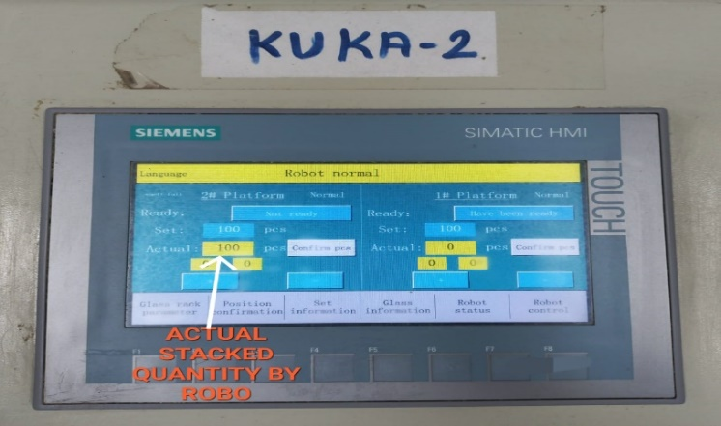
- If the glass stacked manually at End of the line:  Count the glass manually using the white board marker  Note: do not use permanent marker (as shown in the picture) |  |  |  |  |  | 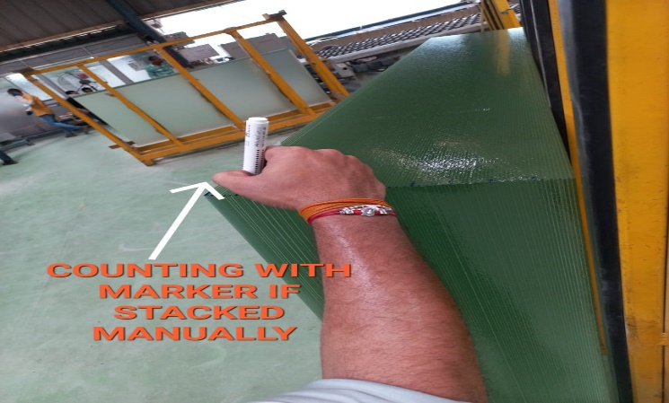
- Inspection of the glass pile:  After confirming the glass sheet count, check the glass rack visually using the torch light and ensure that the glass pile is free from defects such as chipping, breakage, scratches, or abnormal cutting.  Note: this is applicable for both Manual and Robotic rack. |  |  |  |  |  | 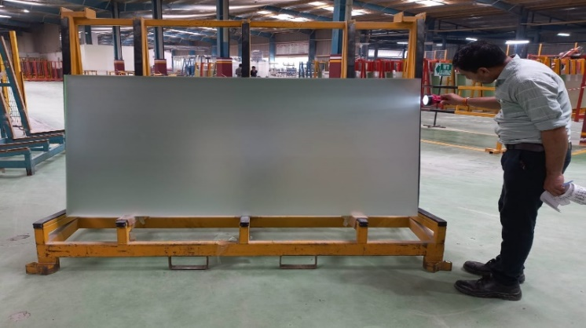
7.1.3 Open SAP HANA:  Double tap on the SAP HANA PRD IP icon. |  |  |  |  |  | 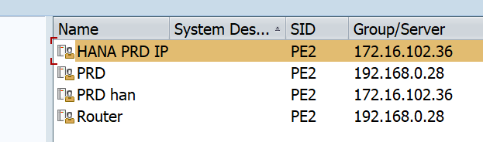
7.1.4 Login to the SAP HANA:  - Enter user ID and password.  - Click "Enter" to log in. |  |  |  |  |  | 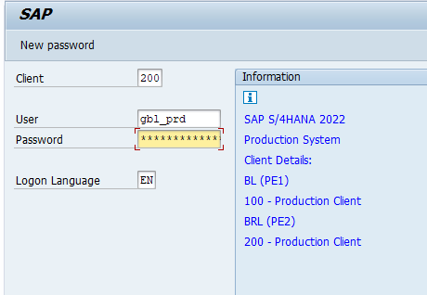
7.1.5 Enter transaction code:  - Type "ZCO01" in the command field.  - Press "Enter" or click "Execute." |  |  |  |  |  | 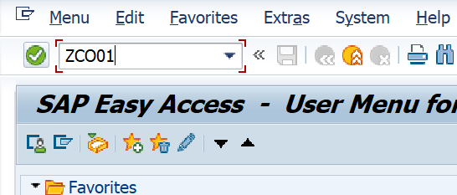
7.1.6 Glass type selection:  Choose either "WIP" or "SOLAR" based on glass type.  - Select WIP – if the material was on stock and need to generate barcode for it.  - Select SOLAR – if material production is going. |  |  |  |  |  | 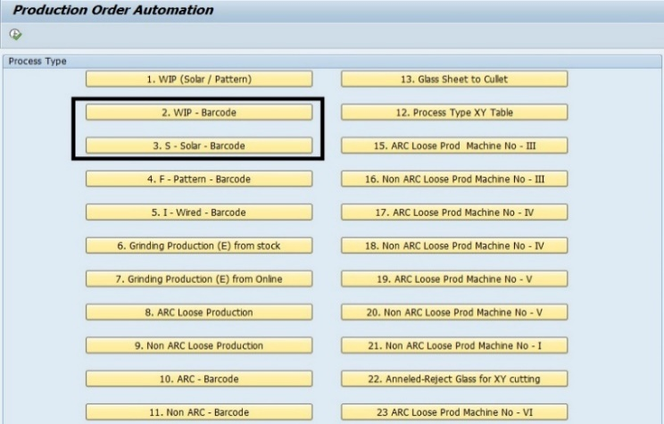
- Fill glass details:  Once you select the type, the page will ask for glass details as below:  - Thickness,  - length,  - width,  - and design  For design:  - AM -Anneal Matt-Matt  - AP – Anneal Pris-Matt  - AX – Anneal Pris-Matt  Press "Enter." |  |  |  |  |  | 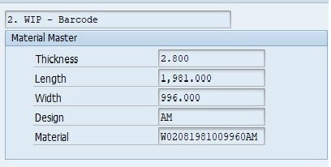
7.1.8 Enter other details:  Enter shift details and the supervisor's name, Line number, no of pcs, storage zone, and rack no.  For line number, Refer the table at right side:
  ANNEAL LINE | MACHINE NO | ANNEAL LINE | MACHINE NO
  SG -1 (LOOSE) | L | SG -3.1 (LOOSE) | N
  SG -1(WIP) | W | SG -3.1 (ANNEAL) | 21
  SG -1 (ANNEAL) | 8 | SG -3.2 (LOOSE) | O
  SG - 2 (LOOSE) | K | SG -3.2 (ANNEAL) | 22
  SG -2 (WIP) | M
  SG - 2 (ANNEAL) | 0
7.1.9 FOR QUALITY:  Choose the appropriate code based on the type of interleaving medium used.  - “A” for Paper  - “B” for Powder |  |  |  |  |  | 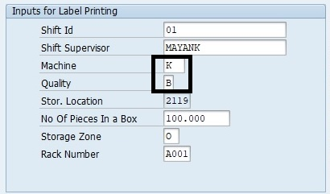
7.1.10 Production detail:  - Enter quantity  - Choose the appropriate code based on the line.  - Then click on the create button. |  |  |  |  |  | 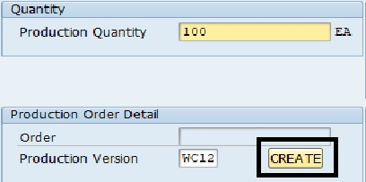
  ANNEAL LINE | PRODUCTION VERSION
  SG -1 | WCL1
  SG -2 | WCL2
  SG -3.1 | WCL3
  SG -3.2 | WCL3
7.1.11 Enter the posting date & click on “POST” button |  |  |  |  |  | 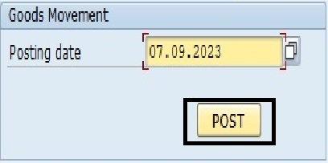
7.1.12 Print barcode:  - Upon posting, note the GR number.  - Click on "Print."  - Check the checkbox for printing the barcode. |  |  |  |  |  | 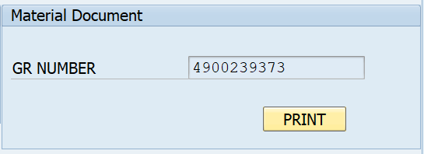
7.1.13 Write down all relevant details in the annealed glass production register. |  |  |  |  |  | 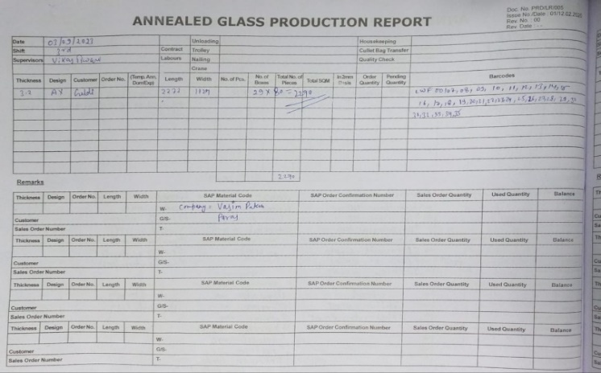
7.1.14 Once the barcode is generated, print it on paper and sign it with a pen. |  |  |  |  |  | 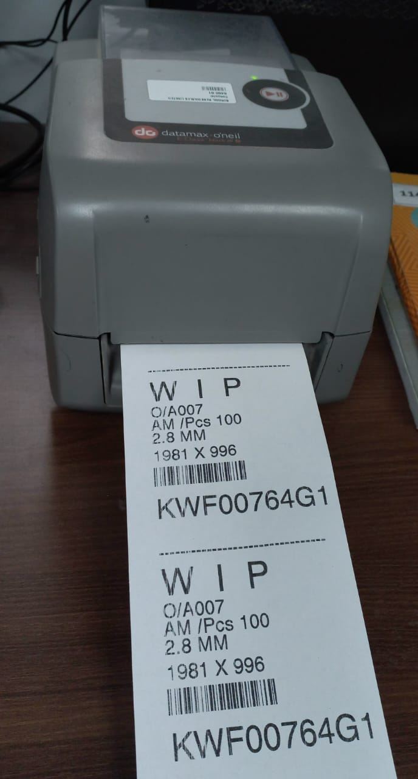
7.1.15 Barcode identification:  - Write the ROBO number (e.g., R1, R2) on the barcode print if it is stacked on the ROBO.  - Write the "M" number on the barcode print if it is stacked manually. |  |  |  |  |  | 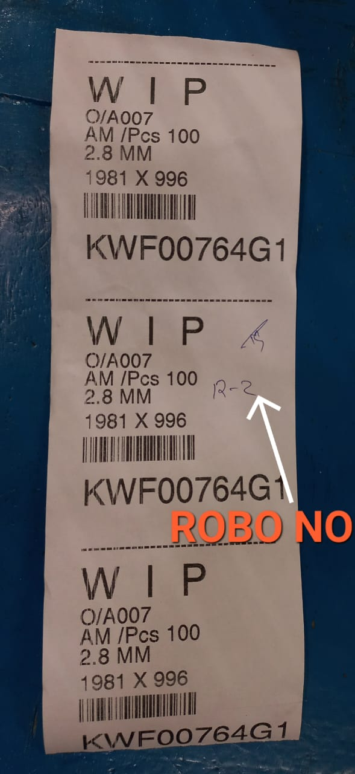  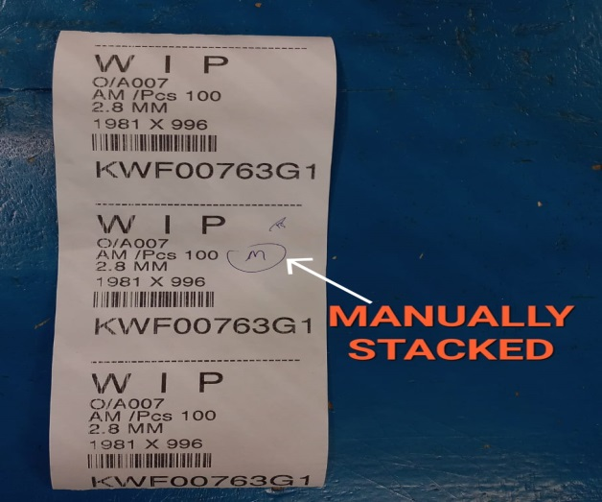
7.1.15 Placing the barcode in the glass pile:  Insert the printed barcode inside the glass pile for easy identification and tracking.  Note: the barcode should be placed after 1 sheet  Note: Double check the size and other details before placing the barcode in the glass rack. |  |  |  |  |  | 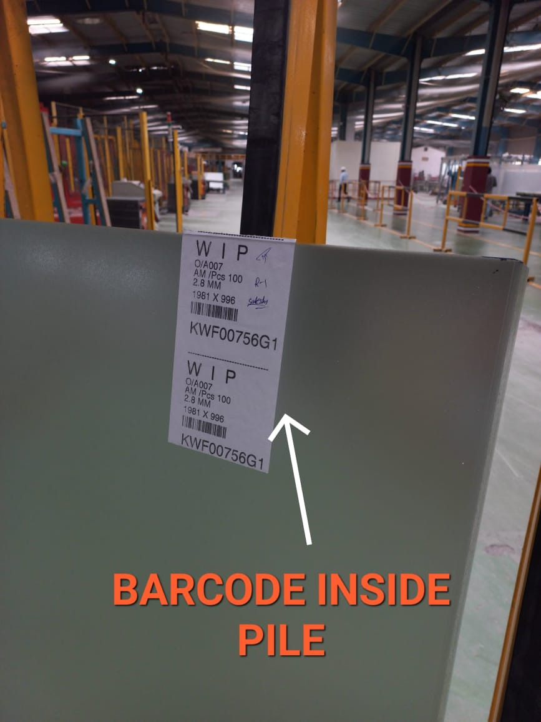
7.2 Special Process Requirements
7.2.1 Not applicable
7.3 Prevention & Detection Controls
7.3.1 Before taking any additional steps, verify all the details. If you find any problems, contact the shift in charge.
7.3.2 Place the barcode after matching the glass and barcode detail.

7.4 Controls Related to EHS
7.4.1 PPE MATRIX
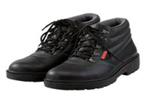 |  | 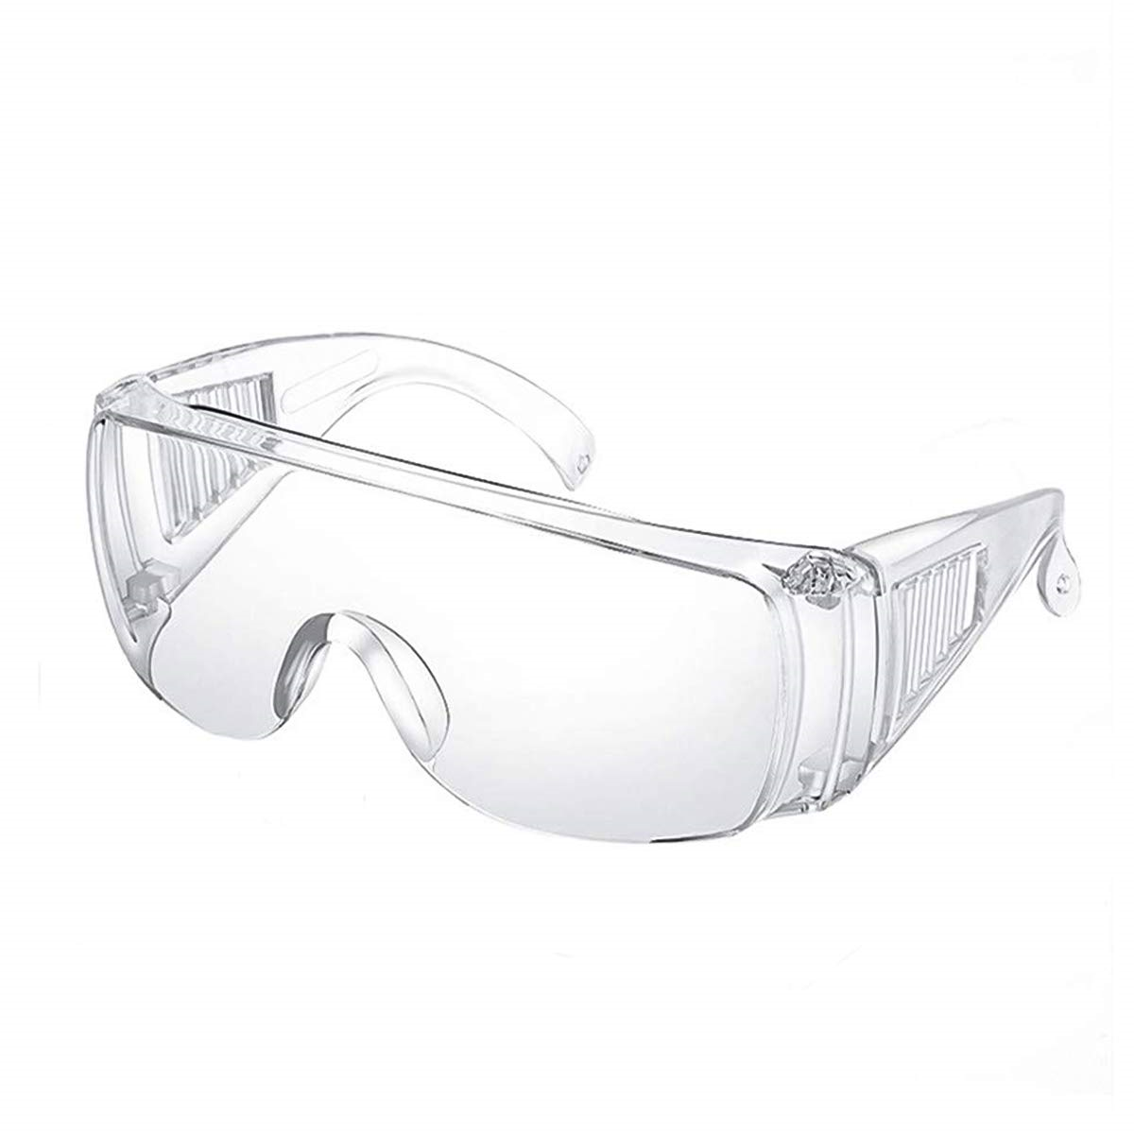
Safety Shoes |  | Safety goggles
7.4.2 Used paper needs to be disposed of in designated bin.

8.0 EHS Compliance Obligations
8.1 Not applicable
9.0 Possible deviation & Impacts |  |  |  |  |  |  | 10. Proposed actions
9.1 Stock or quantity and annealed production will be affected by the wrong barcode. |  |  |  |  |  |  | 10.1 Do every step carefully and in detail.
11. Reference documented information
11.1 Barcode slip. – PRD/L4/xxx
11.2 WIP packing register. - PRD/L4/xxx
12. Revision History
Revision No. | Date |  | Description of changes
00 | 01.07.2023 |  | Initial release
01 | 02.12.2025 |  | Format standardized, revision history added, step correction done.

